**IBM Applied Data Science Program**

**Capstone Project Report**

For this week, you will required to submit the following:

1. A description of the problem and a discussion of the background. (**15 marks**)
2. A description of the data and how it will be used to solve the problem. (**15 marks)**

For the second week, the final deliverables of the project will be:

1. A link to your Notebook on your Github repository, showing your code. (**15 marks**)
2. A full report consisting of all of the following components (**15 marks**):

* Introduction where you discuss the business problem and who would be interested in this project.
* Data where you describe the data that will be used to solve the problem and the source of the data.
* Methodology section which represents the main component of the report where you discuss and describe any exploratory data analysis that you did, any inferential statistical testing that you performed, if any, and what machine learnings were used and why.
* Results section where you discuss the results.
* Discussion section where you discuss any observations you noted and any recommendations you can make based on the results.
* Conclusion section where you conclude the report.

3. Your choice of a presentation or blogpost. (**10 marks**)

**Introduction & Business Plan**

For this project we will consider an entrepreneurs business proposal for establishing a Bahamian themed restaurant in Toronto.

In recent years, Canada has opened its boarders to the international community for those wishing to migrate and start a new life in Canada. Many of the persons who have been migrating are from the Caribbean. With Canada having one of the most culturally diverse societies, it is not surprising that you would see restaurants and other cultural-themed businesses pop-up throughout communities and cities. It’s important to consider this problem as many persons from these countries will look at establishing themselves in order to create employment and/or as a means of sharing their culture with the residents of Toronto. So, we are going to take a look around and identify options since we will not be using demographic data.

**Data Collection**

In order to approach this problem, I will be using location data obtained from the Foursquare API about neighborhoods in Toronto that feature similar Caribbean-themed restaurants which should give us an indication of what areas would experience higher volumes of Caribbean people.

**Methodology**

An exploratory view of the data of the city should prove sufficient for satisfying the problem at hand. The first task was to import and sort through the geographical data having identified Toronto’s Boroughs and neighborhoods. Having scraped a Wikipedia page of the Borough information, the information was placed in a data frame and further cleaned up to disregard unneeded information. It is confirmed that Toronto has 5 Boroughs consisting of 106 Neighborhoods. The geographical coordinates would also have been gathered which will be useful further in the analysis.

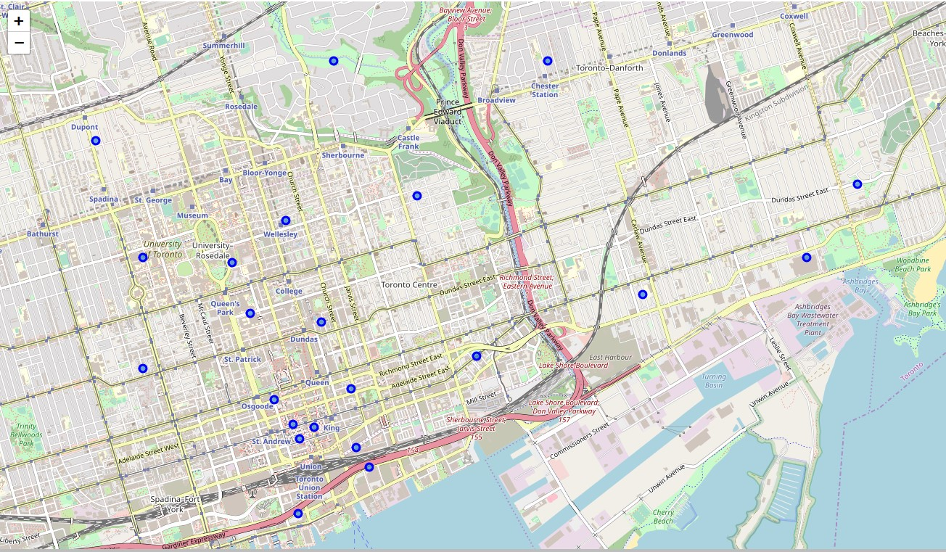

Fig.1. Neighborhood level view of Toronto

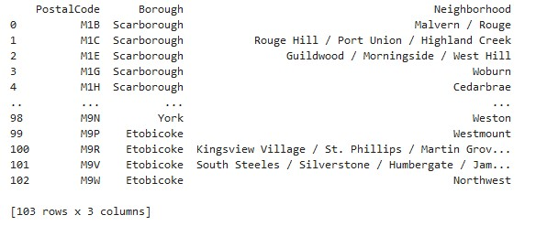

Fig.2. Table of the neighborhoods in Toronto.

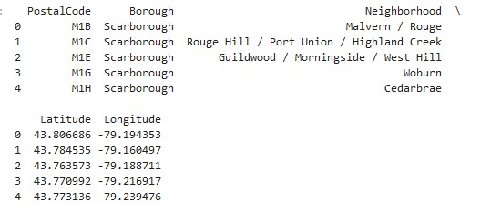

Fig.3. Coordinates of neighborhoods.

A map of Toronto is generated as seen in Fig.1 indicating the coordinates of a number of the neighborhoods in this view.

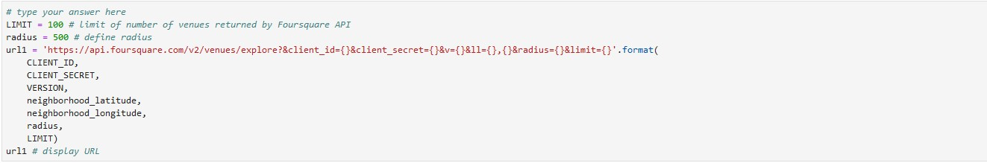

Here the Foursquare API is engaged in order to perform a scan of the venue types in each neighborhood was done to shows what kind of businesses we would find. Fig.5 starts to show what types of businesses and how much of them are present. The snapshot highlights the top ten business types with a total frequency value of 1 in alphabetical order by neighborhood.

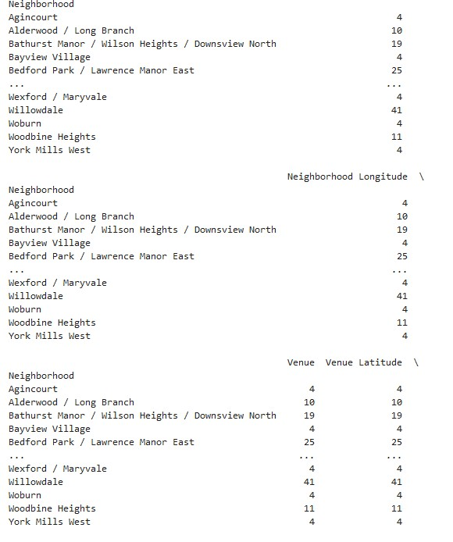

Fig.4. Umbrella view of number of neighborhood business venues.

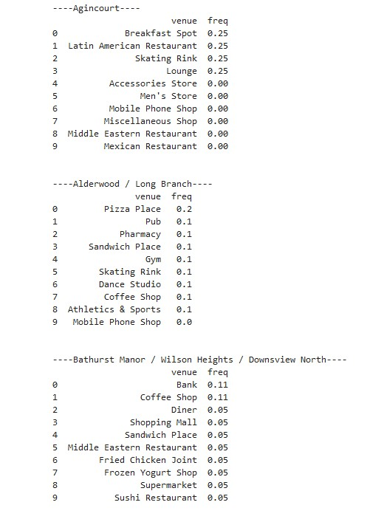

Fig.5. Frequency view of venue types.

**Results**

Looking at the results of the venue searches, a number of trends can be observed:

* Most common themed restaurants are Asian followed by European and Middle Eastern.
* Fast food restaurants and take outs are also common.
* Caribbean themed restaurants are few in number and not as common in Boroughs.

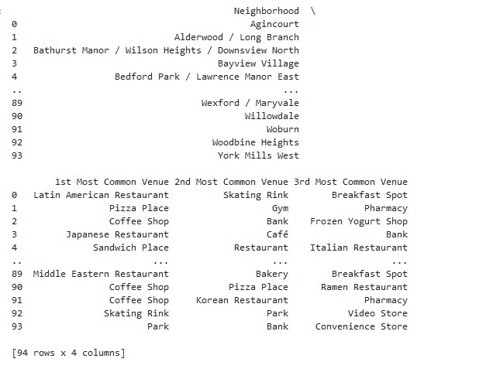

Fig.6. Most common venues in Toronto neighborhoods.

**Discussion**

Based on what we are seeing in the exploratory data is that there is market opportunity for more Caribbean themed restaurants in Toronto. If we look at

**Conclusion**

Fair to say that there are ample opportunities for immigrants to find ideal locations for food-based businesses in most if not all areas of Toronto. This model can be utilized for any other business type.